# 

**ELECTROMAGNETIC INTERFERENCE (EMI ) AND ELECTROMAGNETIC COMPATABILITY TESTING**

# INTERNSHIP PROJECT REPORT

# Submitted by

# Biancaa.R

# III year

# ECE DEPT

# unnamed.jpgSSN COLLEGE OF ENGINEERING

**INTERNED IN CVRDE DRDO -EMI / EMC**



**From 16.7.24 to 17.8.24,under the guidance of**

**Mr. Phanikrishna P sir, Scientist ‘E’**

**ACKNOWLEDGEMENT:**

I wish to express my profound and heartfelt gratitude to the esteemed organization, CVRDE DRDO (Combat Vehicles Research and Development Establishment, Defence Research and Development Organisation), for bestowing upon me the exceptional opportunity to undertake this prestigious internship.

At the outset, I extend my deepest and most sincere thanks to the distinguished Head of Department, Dr. P. Vijayalakshmi, whose unwavering support and gracious encouragement have been instrumental in facilitating my participation in this invaluable internship. Her benevolent guidance has been the cornerstone upon which this report stands, and without her visionary leadership, this endeavor would have remained a distant aspiration.

I am profoundly indebted to PalaniKumar sir of the FV Department, whose expertise and unwavering support have been a constant source of inspiration throughout the course of this internship.

My heartfelt gratitude also extends to

P. Phani Krishna sir, Scientist 'E', and K. Gurusankar sir, TO 'A', whose exceptional mentorship and guidance have been invaluable. Additionally, I would like to convey my genuine appreciation to Sandeep Kumar sir, STA 'B', Jayapriya ma,am, JRF, and Raghav sir of the Vehicle Communication Division – EMI/EMC, for their steadfast support, encouragement, and invaluable insights, which have significantly enriched my experience during this internship.

My heartfelt thanks are also extended to the remarkable team with whom I had the privilege of collaborating. Their camaraderie, dedication, and shared vision have made this journey not only enlightening but also profoundly rewarding.

In essence, this journey has been illuminated by the collective efforts, wisdom, and unwavering support of these esteemed individuals, without whom this endeavor would not have reached its successful fruition. Their contributions have not only shaped this internship but have also left an indelible mark on my professional and personal growth, for which I am eternally grateful.

**ABSTRACT**

This report provides an in-depth examination of Electromagnetic Compatibility (EMC) and Electromagnetic Interference (EMI) testing within the Defence Research and Development Organization (DRDO). The primary objectives of EMC/EMI testing include ensuring the operational integrity, compliance with stringent standards, safety, and reliability of defence systems. To achieve these goals, DRDO employs a multifaceted approach, leveraging advanced facilities such as anechoic chambers, reverberation chambers, open-area test sites, and shielded enclosures.

The testing process is thorough and systematic, beginning with the design review phase and extending through to post-compliance monitoring. This rigorous process ensures adherence to standards such as MIL-STD-461, which is pivotal for maintaining high performance and reliability. The report details the comprehensive testing procedures for emissions and susceptibility, including specialized tests such as RE102 (Radiated Emissions), RS103 (Radiated Susceptibility), CE102 (Conducted Emissions).

Furthermore, the report delves into essential topics such as field calibration, the use of spectrum analysers, ambient measurement techniques, and attenuation measurement. It also covers the control of Vector Network Analysers (VNAs) through Standard Commands for Programmable Instruments (SCPI), the conversion of dBm to dBµV, the interpretation of S-parameters, and the analysis of antenna radiation patterns. Additionally, the report includes discussions on Ultra-Sensitive Detection Systems (USDS) and provides experimental images of tests conducted at the Combat Vehicles Research and Development Establishment (CVRDE).

This comprehensive report underscores DRDO's unwavering commitment to ensuring the reliable performance of its systems within complex electromagnetic environments. It highlights the organization's dedication to maintaining the highest standards of operational excellence and safety in defence technology.

**Defence Research and Development Organisation (DRDO)**

The Defence Research and Development Organisation (DRDO) is the research and development (R&D) wing of India's Ministry of Defence. DRDO's mission is to develop and produce state-of- the-art weapon systems, defense equipment, and sensors for the Indian Armed Forces. DRDO also aims to achieve self-reliance in critical defense technologies and systems, and to equip the armed forces with cutting-edge defense technologies.DRDO has a network of 52 laboratories that work in various fields, including aeronautics, armaments, electronics, land combat engineering, life sciences, materials, missiles, and naval systems. The organization employs around 5,000 scientists and 25,000 other scientific, technical, and supporting personnel. DRDO has achieved many successes since its inception, including developing major systems and critical technologies such as aircraft avionics, UAVs, small arms, artillery systems, EW systems, tanks and armored vehicles, sonar systems, command and control systems, and missile systems

|  |  |  |  |  |
| --- | --- | --- | --- | --- |
| 5  **CONTENTS** | | | | |
|  | **S.NO** | **TITLE** | **PAGE NO** |  |
| 1. | Introduction to MIL STD 461F | 9 |
| 2. | Anechoic chamber  2.1.Types of anechoic chamber 2.2.Construction of anechoic chamber 2.3.Materials used for anechoic chamber 2.4.Applications of anechoic chamber | 9-12 |
| 3. | Vector Network Analyzer  3.1.VNA vs Spectrum Analyzer 3.2.Need of VNA   * 1. Key Specifications   2. Understanding S Parameters | 13-14 |
| 4. | CE102  4.1.Purpose 4.2.Test equipment 4.3.Test Procedure  4.4.Test setup | 14-18 |
| 5. | RE102  5.1.Purpose 5.2.Requirement 5.3.Test Setup 5.4.Test Equipment | 18-19 |

|  |  |  |
| --- | --- | --- |
|  | 5.5.Testing Procedure |  |
| 6. | RS103  6.1.Purpose 6.2.Requirement 6.3.Test equipment 6.4.Test Procedure  6.5.Test Setup | 20-21 |
| 7. | CS115  7.1.Purpose 7.2.Test Setup 7.3.Test equipment  7.4.Test Procedure | 22-23 |
| 8. | CS116  8.1.Purpose 8.2.Test equipment 8.3.Test Procedure  8.4.Test setup | 24-26 |
| 9. | CS118  9.1.Purpose 9.2.Test setup 9.3.Test equipment  9.4.Test Procedure | 26-28 |

|  |  |  |
| --- | --- | --- |
| 10. | Antenna  10.1.Antenna Beam width 10.2.How beam width is measured  10.3.Accounting for different antenna and frequency 10.4.Gain  10.5.Antenna Measurement 10.6.Antenna Impedance  10.7.Universal Spectral Dipole Source | 28-31 |
| 11. | Controlling of VNA through SCPI commands | 31 |
| 12. | EMI receiver  12.1.Resolution Bandwidth(RBW) 12.2.Phase Noise | 31-32 |
| 13. | Conversion related to dB and power | 32 |
| 14. | Insertion loss measurement of Direction coupler 14.1.Direction coupler   * 1. What is VSWR?   2. How to measure VSWR using Direction coupler 14.4.VSWR of Transmitting Antenna using VNA | 33-36 |
| 15. | Smith chart  15.1.Components of Smith Chart 15.2.Advantages of Smith Chart 15.3.Applications of Smith Chart | 36-39 |
| 16. | Power measurement using USB power sensors  16.1.Average Power | 39-40 |

|  |  |  |
| --- | --- | --- |
|  | * 1. Average power measurement   2. Power sensors in EMI and EMC |  |
| 17. | Performance of Bi-conical Antenna  17.1.Radiation Pattern of Bi-conical Antenna | 40-42 |
| 18. | Conclusion | 42 |
| 19. | Reference | 42 |

**INTRODUCTION**

**Electromagnetic Interference (EMI)** and **Electromagnetic Compatibility (EMC)** are fundamental concepts in the design and development of electronic systems. They are intricately linked, yet distinct, disciplines that are crucial for ensuring the reliable operation of electronic devices in their intended environments.

**Electromagnetic Interference (EMI)**

EMI refers to the unwanted electromagnetic energy that can disrupt the operation of electronic devices, electrical systems, or radio frequency systems. This interference can originate from various sources, including:

* **Conducted EMI:** Transmitted through power or signal cables.
* **Radiated EMI:** Propagated through the air as electromagnetic waves.

Sources of EMI can be man-made (e.g., power supplies, motors, digital circuits) or natural (e.g., lightning, solar flares).

**Electromagnetic Compatibility (EMC)**

EMC is the ability of an electronic device or system to function satisfactorily in its electromagnetic environment without causing unacceptable electromagnetic disturbance to anything else. It encompasses both emission and immunity aspects:

* **Immunity testing** - measures how a device will react when exposed to electromagnetic noise and other disturbances. The purpose of these tests is to gain a reasonable assurance that the device will operate as intended when used within its expected operating environment. The device should be able to withstand electromagnetic disturbances without malfunctioning. EMC standards and regulations have been established to ensure the compatibility of electronic devices and systems, promoting a harmonious electromagnetic environment.
* **Emissions testing** - measures the amount of electromagnetic noise generated by a device during normal operation. The purpose of these tests is to ensure that any emission from the device are below the relevant limits defined for that type of device. ie. The device should not generate excessive electromagnetic energy that interferes with other devices.[5]

**COMMON APPLICATIONS OF EMI/ EMC:**

1. Medical Devices

EMC testing is critical for managing risk in medical device manufacturing. Devices must be able to work together in close environments without interference or noise compromising performance. The FDA requires that all medical devices undergo EMC testing per the appropriate FDA Reviewer Guidance document or the European IEC 60601-1-2 standards. In the EU, all medical devices must have CE marking, which requires both immunity and emissions testing per IEC 60601-1-2.

1. Military/Aerospace Devices

MIL-STD-461 outlines EMC testing requirements for military equipment, including electromagnetic susceptibility and emissions testing. MIL-STD-461 contains relatively stringent electromagnetic compatibility requirements. Devices which are compliant with MIL-STD-461 are typically well-positioned to meet FCC, DO-160 and other standards for avionics equipment, consumer goods and other products.

1. Consumer Goods

Consumer goods such as microwave ovens, cellular phones, laptops and satellite TV dishes all must undergo EMC/EMI testing to ensure they do not cause harmful interference and accept interference without causing undesired operation in real-world conditions. For more information about EMC/EMI testing for different devices, contact Com-Power Corporation directly.

**EMC Testing Routines:**

**(What are the hazardous conditions being simulated?)**

A specific EMC testing routine is determined by the nature of the device being tested, its intended application and and the regulatory requirements governing its use. Electromagnetic phenomena that may be simulated through EMC testing include:

* Magnetic fields, such as those radiating from electrical wires
* Voltage drops due to a brownout or other power interruption
* Electromagnetic surges due to a lightning strike
* Conducted and radiated electromagnetic noise
* Electrostatic discharges associated with static electricity
* Fast transients caused by electrical switches, motors and relays, fluorescent lamp ballasts, for example.

A wide range of equipment is used to simulate the above conditions and determine the ability of a device under test to recover from them. A typical EMC testing lab may utilize [surge generators](https://www.com-power.com/products/surge-generators), [power amplifiers](https://www.com-power.com/products/power-amplifiers), [spectrum analyzers](https://www.com-power.com/products/spectrum-analyzers) and more.

**NOTABLE HAZARDS DUE TO EMC FAILURE:**

**(cite:** **https://ntrs.nasa.gov/api/citations/19960009442/downloads/19960009442.pdf)**

**2.3.3.1 Talking EEG Machine**

This case involved EM1 that prevented proper testing of surgically implanted probes used in monitoring specific portions of a patient's brain activity. With probes in direct brain contact, the potential between any two points is measured on an EEG machine. The EEG provides critical feedback to the surgeon during surgery. This particular EM1 manifested itself on the analog plotting needles of the EEG machine as a modulated signal easily recognized as speech-hence a talking EEG machine! The EMI-caused noise was so severe that it completely,masked the EEG signals and made the machine alarmingly ineffectual during surgery. The signal was from a local AM radio station, and the noise during surgery was from common impedance coupling between the EEG machine and the operating table. Bonding the EEG with the operating table eliminated the EM1 and restored the critical brain monitoring function.

**22 2.3.3.2 Ambulance Heart MonitorAIefibrillator** Susceptibility of medical equipment to conducted or radiated emission is a concern. In this case, a 93-year-old heart attack victim was being taken to the hospital and the medical technician had attached a monitor/defibrillator to the patient. Because the machine shut down every time the technicians turned on the radio transmitter to request medical advice, the patient died. An investigation showed that the monitor/defibrillator was exposed to exceptionally high radiated emissions because the ambulance roof had been changed from metal to fiberglass and fitted with a long-range radio antenna. Reduced shielding combined with the strong radiated radio signal resulted in EM1 to the vital machine.*'

**2.3.3.3 Runaway Wheelchairs** Wheelchairs came under the scrutiny of the FDA (fig. 5) because of reported erratic, unintentional powered-wheelchair movements. These movements included sudden starts that caused wheelchairs to drive off curbs or piers when police, fire, or CB transmitters were activated near the chairs. Although no fatal injuries have been reported, FDA has ordered manufacturers of motorized wheelchairs to shield them from EM1 and to educate users on the potential EM1 hazards.2'

**2.3.1.16 Antilock Biaking System (ABS) Failure** :Early ABS systems on both aircraft and automobiles were susceptible to EMI. Accidents 1 occurred when the brakes functioned improperly because EM1 disrupted the ABS control system. 10 For aircraft, the initial solution was to provide a manual switch to lock out the ABS function when it was inoperable due to EM1 and to use the normal braking system. Later, the solution was to qualify prior to flight the ABS system based on the expected EME. For automobile systems, the solution was to ensure, if EM1 occurs, that the ABS system degrade gracefully to normal braking-ssentially an automatic version of the aircraft manual switch. Eventually, automobile ABS was qualified by EM1 testing prior to procurement.8 ’ Cellular Phone l Laptop Computer Radio Electronic Game CD Player Tape Player AM-FM Recorder AM-FM Walkman Dictaphone Heart Monitor Television

**2.3.1.17 Mercedes-Benz Case Navigation Aids** During the early years of ABS’s, Mercedes-Benz automobiles equipped with ABS had severe braking problems along a certain stretch of the German autobahn. The brakes where affected by a near-by radio transmitter as drivers applied them on the curved section of highway. The nearterm solution was to erect a mesh screen along the roadway to

attenuate the EMI. This enabled the brakes to function properly when drivers applied them.

**STANDARDS OF EMI EMC TESTING:**

|  |  |  |
| --- | --- | --- |
| **Application** | **Common EMC Standard(s)** | **Significance** |
| Medical | IEC 60601-1-2 | This standard regulates the safety and performance of medical equipment and systems under electromagnetic environments. |
| Automotive | SAE, ISO7637, IEC CISPR-25, ISO1145-1, ISO1145-2 | Addresses test procedures, measuring techniques, and the allowable limits of electromagnetic disturbances affecting electrical and electronic components in the automotive sector. |
| Military | MIL-STD-461, DEF STAN 59/411, MIL-STD-704, MIL-STD-1275, MIL-STD-1399 | Regulates the electromagnetic emissions and susceptibility of the systems used in military applications. |
| Industrial | FCC Part 15 class A, EN 61000-6-4 (generic), EN 61000-6-2(generic) | A general set of EMC standards for regulating the intentional, unintentional, or incidental radiations for devices used in commercial, industrial, or business environments. |
| Commercial | FCC Part 15 class B, EN 61000-6-3 (generic), EN 61000-6-1(generic) | Devises the immunity requirements for electrical and electronic equipment used in commercial, public, light-industrial, or residential locations. |
| Switchgear and control | EN/IEC 60947-1 | Regulates low-voltage switch gears and control gears with working voltages within 1500 V DC and 1000 V AC. |
| Power station and substation | IEC TS 61000-6-5 | Sets the immunity levels for the equipment utilized in the generation, transmission, and distribution of electricity. |
| Process control and measurement | EN/IEC 61326-1 | Specifies the immunity and emissions levels of electrical equipment or devices with a working potential less than 1000 Vac and 1500 V DC. |

# MILITARY : General military standard : MIL STD 461F:

This standard establishes interface and associated verification requirements for the control of the electromagnetic interference (EMI) emission and susceptibility characteristics of electronic, electrical, and electromechanical equipment and subsystems designed or procured for use by activities and agencies of the Department of Defence (DoD)

Emission and susceptibility designations. The emissions and susceptibility and associated test procedure requirements in this standard are designated in accordance with an alphanumeric coding system. Each requirement is identified by a two-letter combination followed by a three- digit number. The number is for reference purposes only. The meaning of the individual letters is as follows, (C = Conducted, R = Radiated, E = Emission, S = Susceptibility)

* 1. Conducted emissions requirements are designated by "CE"
  2. Radiated emissions requirements are designated by "RE"
  3. Conducted susceptibility requirements are designated by "CS"
  4. Radiated susceptibility requirements are designated by "RS"

1. 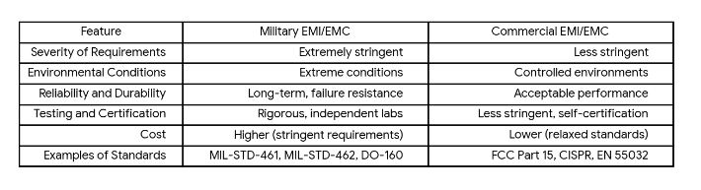**DIFFERENCE BETWEEN THE COMMERCIAL AND MILITARY STANDARDS:**

**ENVIRONMENT FOR THE EMI EMC TESTING:**

An EMI/EMC (Electromagnetic Interference/Electromagnetic Compatibility) chamber is a specialized facility designed to test and measure the electromagnetic emissions and susceptibility of electronic and electrical devices. The chamber's design and construction incorporate several key qualities that ensure accurate, repeatable, and reliable testing. Here are the essential qualities of an EMI/EMC chamber:

**QUALITIES OF EMI EMC CHAMBER:**

**1. Electromagnetic Shielding**

* **Faraday Cage Construction:** The chamber is typically built within a Faraday cage, a conductive enclosure that blocks external electromagnetic fields. This prevents external RF (Radio Frequency) interference from affecting the tests conducted inside the chamber.
* **High Shielding Effectiveness:** The materials and construction techniques used in the chamber provide high levels of shielding effectiveness, typically measured in decibels (dB). This effectiveness is crucial for isolating the chamber from external electromagnetic environments.

**2. Low Reflectivity**

* **RF Absorber Materials:** The interior surfaces of the chamber are lined with RF absorber materials, such as carbon-loaded foam pyramids or ferrite tiles. These materials minimize the reflection of electromagnetic waves within the chamber, creating a non-reflective environment that simulates free space.
* **Minimized Internal Reflections:** The chamber is designed to reduce internal reflections, ensuring that the only electromagnetic energy detected during testing is that which is intentionally emitted or received by the device under test (DUT).

**3. Controlled Environment**

* **Temperature and Humidity Control:** The chamber may include systems to control temperature and humidity, ensuring that environmental factors do not influence the test results.
* **Vibration Isolation:** The chamber is often built on a foundation isolated from the rest of the building, minimizing the effects of external vibrations on sensitive measurements.

**4. Precision Measurement Capabilities**

* **Accurate Calibration:** The chamber is equipped with calibrated measurement equipment, ensuring that all tests conform to established standards and provide accurate, reliable results.
* **Broad Frequency Range:** The chamber and its equipment are capable of testing across a broad range of frequencies, often from a few kHz to several GHz, to cover the requirements of various standards like MIL-STD-461, CISPR, and FCC regulations.

**5. Versatility**

* **Multi-Purpose Testing:** EMI/EMC chambers are designed to accommodate a wide range of tests, including radiated emissions, conducted emissions, radiated susceptibility, and conducted susceptibility. This versatility allows for comprehensive testing of a device's electromagnetic performance.
* **Customizable Configuration:** The chamber can be configured with different antennas, receivers, and other equipment to meet the specific testing requirements of various industries, including military, aerospace, automotive, and consumer electronics.

**6. Compliance with Standards**

* **Adherence to International Standards:** The chamber and its testing procedures are designed to comply with international standards such as MIL-STD-461, CISPR 16, and IEC 61000-4 series, ensuring that the tests meet industry and regulatory requirements.
* **Certification and Validation:** The chamber is often certified by recognized authorities, and its performance is regularly validated through testing and calibration.

**7. Safety Features**

* **Personnel Protection:** The chamber is equipped with safety features to protect personnel from exposure to high levels of RF energy, including interlocks, warning systems, and emergency shut-off controls.
* **Proper Grounding:** Effective grounding systems are in place to prevent electrical hazards and ensure the integrity of measurements.

**8. Ease of Use**

* **User-Friendly Interface:** Modern EMI/EMC chambers often include sophisticated software interfaces that simplify the setup, execution, and analysis of tests.
* **Automated Testing Capabilities:** Automation systems within the chamber allow for repeatable and efficient testing, reducing human error and improving consistency in results.

**9. Flexibility in Size and Design**

* **Scalable Dimensions:** EMI/EMC chambers come in various sizes, from small benchtop chambers to large walk-in rooms, allowing for the testing of devices of different sizes, from small components to full-scale systems.
* **Modular Design:** Many chambers are modular, allowing for future expansion or reconfiguration to accommodate new testing requirements or standards.

**10. Reliability and Durability**

* **Long-Term Stability:** The chamber is constructed with materials and components that offer long-term stability, ensuring that the chamber maintains its performance over many years of use.
* **Resilience to Wear and Tear:** High-quality construction materials ensure that the chamber can withstand frequent use without degradation in performance

# ANECHOIC CHAMBER

An-echoic meaning “non-reflective” or “without echoes” is a room designed to stop reflections or echoes of either sound or electromagnetic waves. They are also often isolated from energy entering from their surroundings. This combination means that a person or detector exclusively hears direct sounds (no reflected sounds), in effect simulating being outside in a free fiel

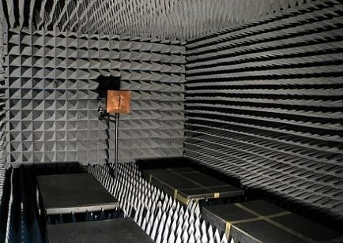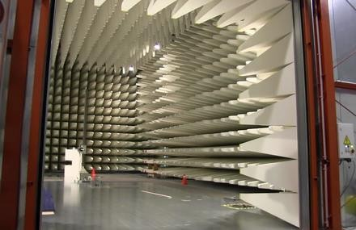

**Fully Anechoic Chamber: Semi Anechoic chamber:**

An anechoic chamber is a shielded room designed to suppress sound and/or electromagnetic energy. It is designed to suppress the electromagnetic wave energy of echoes such as reflected electromagnetic waves from the internal surfaces and to provide effective isolation from the acoustic or RF noise present in the external environment. Anechoic chambers are also used to accurately measure an antenna’s gain, efficiency, and radiation patterns. These antennas are vital components for communication of almost all devices ranging from satellites, military vehicles, aircrafts, mobile phones, etc. The chambers are also used to test radiations for medical devices such as X-ray, MRI, CT-scan machines, etc.

# Types of anechoic chamber :

1.Acoustic anechoic chambers 2.RF anechoic chambers

# Construction of anechoic chamber :

In order to make the anechoic chambers free of reflection, the interior surfaces of the RF anechoic chamber are covered with radiation absorbent material (RAM). The most common absorber is made of carbon loaded foam shaped like a pyramid. Sharp tips on the absorbers help

to absorb RF waves without letting them from bouncing off. Due to its shape, the amount of RF that bounces off anechoic chamber walls is often 0.1% to 1% (-30 to -20 dB) of the original wave. The one in the EMI EMC testing facility was constructed by ETS Lindgren, an ESCO testing company.These anechoic chambers have a high-performance wall panel system that provides the low-noise environment required to test today’s low-noise products

# Materials used in anechoic chamber construction:

* + - Foam RF Absorber.
    - EMC Chamber Filters.
    - RF Shielded Doors.
    - EMC Shielded Cameras.
    - EUT Transient Monitors.
    - Data Transmission.

# Shielding Enclosures:

To prevent interaction between the EUT and the outside environment, shielded enclosures will usually be required for testing. These enclosures prevent external environment signals from contaminating emission measurements and susceptibility test signals from interfering with electrical and electronic items in the vicinity of the test facility.

# Radio Frequency (RF) absorber material:

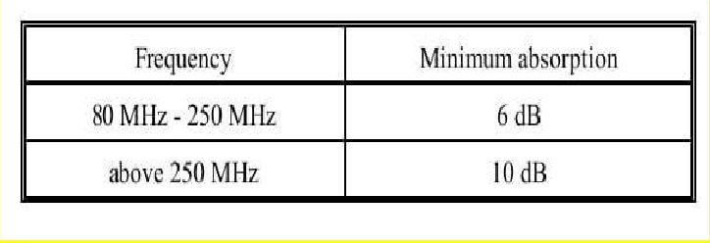RF absorber material (carbon impregnated foam pyramids, ferrite tiles, and so forth) shall be used when performing electric field radiated emissions or radiated susceptibility testing inside a shielded enclosure to reduce reflections of electromagnetic energy and to improve accuracy and repeatability. The RF absorber shall be placed above, behind, and on both sides of the EUT, and behind the radiating or receiving antenna as shown in the below figure. Minimum performance of the material shall be as specified in Table I. The manufacturer's certification of their RF absorber material (basic material only, not installed) is acceptable.

**Faraday Cage**: The chamber is built inside a Faraday cage, which is a structure, made of conductive material (such as metal mesh or plates) that blocks external electromagnetic fields. This prevents external RF interference from entering the chamber and affecting the tests.

**Grounding**: The Faraday cage must be properly grounded to ensure it effectively shields against electromagnetic interference.

# Structural Foundation:

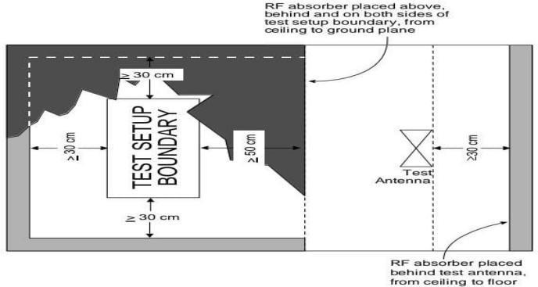**Foundation**: Similar to acoustic anechoic chambers, RF anechoic chambers have a solid, vibration-free foundation, often isolated from the rest of the building to minimize external noise and vibrations.

**Absorber Panels**: The interior surfaces (walls, floor, and ceiling) are lined with RF absorber materials, typically made from foam or rubberized materials impregnated with carbon or ferrite. These materials absorb RF energy, preventing reflections and creating a non-reflective environment.

# Applications of Anechoic chamber :

**EMI Testing**: Testing devices for electromagnetic interference to ensure they do not emit excessive RF energy that could interfere with other devices.

**EMC Testing**: Ensuring that devices can operate correctly in their intended electromagnetic environment without being affected by external RF interference.

**Antenna Testing:** Measuring the radiation patterns and performance of antennas in a controlled environment.

**Wireless Communication Testing:** Evaluating the performance of wireless devices such as mobile phones, Wi-Fi routers, and other RF communication equipment.

In summary, the construction of an RF anechoic chamber involves creating a shielded environment using a Faraday cage and lining the interior with RF absorber materials. This combination ensures that the chamber is free from external RF interference and internal reflections, providing a reliable space for EMI/EMC testing and other RF measurements.

%model shielding enclosures and analyze electromagnetic interference from slots or apertures in the enclosure excited by the interior sources. Enclosure and the interior source is modeled using custom 3-D shapes and performance is evaluated at a particular distance away from the setup.

% The integrity of shielding enclosures for high-speed digital designs is compromised by slots and apertures for heat dissipation,

% CD-ROMs, input/output (I/O) cable penetration, and plate-covered unused connector ports among other possibilities.

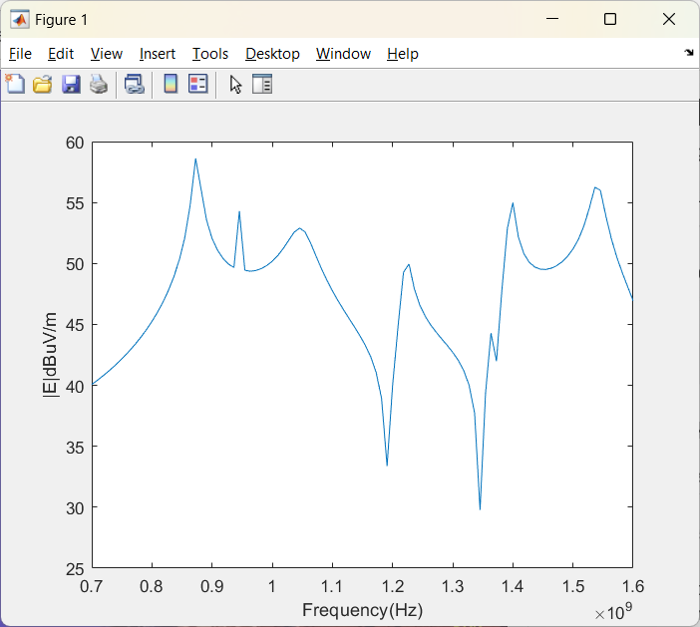enclosureLength = 220e-3;

enclosureWidth = 300e-3;

enclosureHeight = 140e-3;

slotLength = 2e-3;

slotWidth = 120e-3;

box = shape.Box(Length=enclosureLength, Width=enclosureWidth, Height=enclosureHeight);

slot = shape.Box(Length=enclosureLength/2, Width=slotWidth, Height=slotLength, Color="r");

box.Transparency = 0.3;

[~] = translate(slot,[enclosureLength/2 0 -50e-3]);

boxEnclosure = box - slot;

[~] = translate(boxEnclosure,[0 0 40e-3]);

show(boxEnclosure);

feed = shape.Circle(Radius=0.8e-3, Center=[0.05 0], NumPoints=20, Color="r");

[~] = translate(feed,[0 0 -0.11]);

[~] = rotateY(boxEnclosure,180);

antShape = extrude(boxEnclosure,feed,Height=0.12);

[~] = rotateY(antShape,180);

show(antShape)

ant = customAntenna(Shape=antShape);

[~] = createFeed(ant,[-0.05 0 0.11],20);

show(ant);

[E,H] = EHfields(ant,linspace(0.7e9,1.6e9,100),[3 0 0]');

%Calculate the E-field magnitude.

Et = abs(E);

Et = sqrt(Et(1,:).^2+Et(2,:).^2+Et(3,:).^2);

plot(linspace(0.7e9,1.6e9,100),10*log10(Et./1e-6));

xlabel("Frequency(Hz)");

ylabel("|E|dBuV/m");

As seen from the E-field magnitude plot across the 700 MHz to 1.6 GHz frequency range, electromagnetic interference is significant when the larger dimension of the slot is comparable to half-wavelength at the respective frequency of operation used for plotting of the graphs.

**COMPONENTS USED IN EMI/ EMC TESTING:**

# VECTOR NETWORK ANALYSER

Vector Network Analysers (VNA) are versatile instruments for RF test and measurement applications, combining generators and receivers in a single box. They work in a wide frequency range and have powerful computers for fast data processing and controlling external equipment. The combination of VNAs and external switch matrices increases flexibility in RF test applications, allowing simultaneous testing of multiple test objects, complex digitally controlled RF modules, and simultaneous connection of prototypes as indicated in Fig1.

# Vector Network Analyzer | Siglent Network Analyzer | VNAVNA vs Spectrum Analyzer

The OSP switch matrix can be set and its effects observed simultaneously at the VNA. The entire configuration can be stored permanently using "paths" with appropriate pathnames.

The OSP panel software can be closed once all paths are defined and stored. This solution is useful for a Spectrum Analyzer (SA) in 2-port analysis, especially when switching RF paths or modifying DC bias values using digital outputs.

# Need of VNA

Wireless solutions, including smartphones, WiFi networks, connected cars, and IoT devices, use transmitters and receivers with RF and microwave components. VNAs are used to test component specifications and verify design simulations, ensuring system functionality. They are commonly used by R&D engineers and manufacturing test engineers at various stages of product

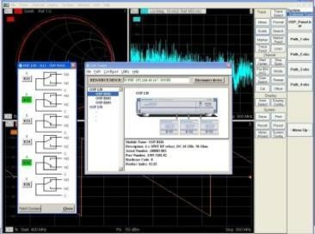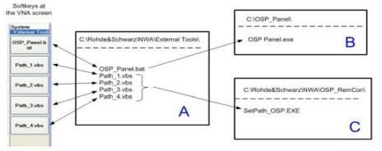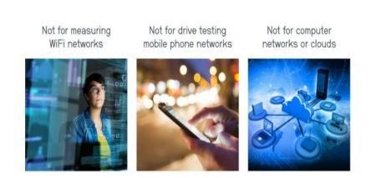

development, component designers, system designers, manufacturing lines, and even in field operations to verify and troubleshoot deployed RF and microwave systems.

# Key specifications :

To select a VNA, consider four top-level specifications: frequency range, dynamic range, trace noise, and measurement speed. Frequency range is crucial, considering both immediate and future needs. Active components may need to be tested at their harmonic frequencies, which can be a cost driver. Dynamic range is the measurable attenuation range from max to min for a specified frequency range. Most VNAs offer good dynamic range (~120 dB), but high- performance components may require more expensive solutions.

# Understanding S-Parameters:

Scattering parameters or S-parameters are used to characterize the electrical properties or performance of an RF component or network of components. They are related to familiar measurements such as gain, loss, and reflection coefficient. A VNA (Visual Network Analyzer) is used to characterize a DUT by using incident and reflected waves as excitations at each port. The S-parameters are constants that characterize the network under these conditions.

In the Forward case, the S-parameters correspond to the reflection coefficient at Port 1 and the forward transmission coefficient through the DUT. In the Reverse case, the S-parameters

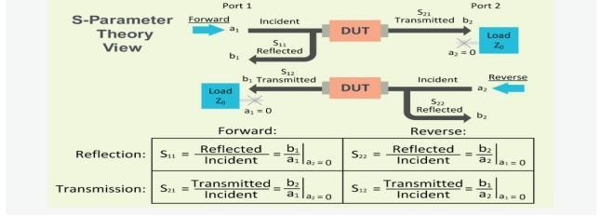

correspond to the reflection coefficient at Port 2 and the reverse transmission coefficient through the DUT.

**SCPI COMMANDS IN VNA:**

SCPI is a Python-based collection of mathematical algorithms and convenience functions, offering high-level commands and classes for data manipulation and visualization. It rivals systems like MATLAB, IDL, Octave, R-Lab, and SciLab.

Basing SCPI on Python allows for sophisticated programming and specialized applications, including parallel programming, web and database subroutines, and classes, making it a powerful tool for Python developers.

**EXAMPLES DEVELOPED:**

#The diagram area in a VNA typically refers to the graphical display where measurement results such as S-parameters (scattering parameters) are plotted.

* 1. Display screen

from rohdeschwarz.instruments.vna import Vna

# Connect

vna = Vna()

vna.open_tcp()

vna.write('DISP:RFS 80')

vna.write(':DISP:WIND:TRAC:X:OFFS 1MHZ; ')

#display window trace offset x axis

vna.query('DISP:WIND:TRAC:Y:OFFS? ')

#Querying all the traces

vna.write("CALC4:PAR:SDEF 'Ch4Tr1', 'S11' ")

# Create channel 4 and a trace named Ch4Tr1 to measure the input reflection

# coefficient S11.

vna.write('DISP:WIND2:STAT ON ')

#Create diagram area no. 2.

vna.write("DISP:WIND2:TRAC9:FEED 'CH4TR1' ")

# Display the generated trace in diagram area no. 2, assigning the trace number

# 9 to it.

vna.write('DISP:WIND2:TRAC9:Y:RLEV -10 ')

# # DISP:WIND2:TRAC9:Y:RLEV -10

# # or: DISP:WIND2:TRAC:Y:RLEV -10, 'CH4TR1'

# Change the reference level to –10 dB.

2.Pulse generation:

from rohdeschwarz.instruments.vna import Vna

# Connect

vna = Vna()

vna.open_tcp()

vna.write('SENS1:PUL:GEN1:TR:DA')

#gen number

# 1 for pulse generator, 2 for sync

vna.write('SENS1:PUL:GEN1:PER125NS')

vna.query('SENS1:PUL:GEN1:TR:SEGM:CO?')

#Pulse train segment number. This suffix is ignored; the command counts all segments.

seg=1

scpi='SENS1:PUL:GEN1:TR:SEGM{}:ST5'

vna.write(scpi.format(seg))

'''Parameters SINGle – Single pulse

CHIGh – Constant high

CLOW – Constant low

TRAin – Pulse train (available for pulse generator signal only, <gen_no> = 1)'''

vna.write('SEN1:PUL:GEN1:TYTR')

vna.write('SENS1:PUL:GEN1:TR:SEGM[:STE]OFF')

vna.write('SENS1:PUL:GEN1:TR:DELE:ALL')

'''Range [def.

unit]

12.5 ns to 54975.5813632 s [s]. The minimum width of a pulse is 12.5 ns, its

maximum width is given by the pulse train period

([SEN<CH>:]PUL:GEN<GEN_NO>:TR:PER).'''

3)REFLECTION COEFFICIENT:

from rohdeschwarz.instruments.vna import Vna

import time

# Connect

vna = Vna()

vna.open_tcp()

vna.write(':SYST:DISP:UPD ON')

vna.write("CORR:COLL:METH:DEF 'Test1',RSHort,1 ")

vna.write('CORR:COLL:SEL SHOR,1 ') #calibration sweep

vna.write('CORR:COLL:SAVE:SEL ')

time.sleep(300)

#Define a reflection normalization with a Short standard at port 1, perform the

#calibration sweep, and apply the calibration to the active channel.

vna.write("CORR:COLL:METH:DEF 'Test2',REFL,1 ")

vna.write("CORR:COLL:SEL OPEN,1")

vna.write('CORR:COLL:SAVE:SEL')

#Define a reflection normalization with an Open standard at port 2, perform the

#calibration sweep, and apply the calibration to the active channel.

vna.query('CORRection:DATA:PARameter1? TYPE ')

#Query the calibration type of the first calibration. The response is RSH.

vna.query('CORRection:DATA:PARameter2? TYPE')

#Query the calibration type of the second calibration. The response is REFL.

vna.query('CORRection:DATA:PARameter:COUNt? ')

#Query the number of active calibrations. The response is 2.

# REFL

# RSH

# Refl Norm Open

# Refl Norm Short

4) SCREENSHOT CAPTURE:

from rohdeschwarz.instruments.vna import Vna

# Connect

vna = Vna()

vna.open_tcp()

temp_filename = 'temp.png'

local_filename = 'screenshot.png'

scpi = ":MMEM:NAME '{0}'"

scpi = scpi.format(temp_filename)

vna.write(scpi)

# Set format

# Options include:

# - BMP

# - PNG

# - JPG

# - PDF

# - SVG

vna.write(":HCOP:DEV:LANG PNG")

# Set contents of screenshot

# to entire screen

vna.write(":HCOP:PAGE:WIND HARD")

# - OR -------------------------

# Set active diagram

diagram = 1

scpi = "DISP:WIND{0}:MAX 0"

scpi = scpi.format(diagram)

vna.write(scpi)

# Set contents of screenshot

# to active diagram

scpi = ":HCOP:PAGE:WIND ACT"

#hard copy of the page in active diagram region

vna.write(scpi)

# ------------------------------

# Set destination to file

vna.write("HCOP:DEST 'MMEM'")

# Save file

# Wait for save to complete

vna.write(":HCOP")

vna.query("*OPC?")

# Copy screenshot off vna

# (See file_transfer.py for details)

vna.file.download_file(temp_filename, local_filename)

# Delete temp file off vna

# Wait for delete to complete

scpi = "MMEM:DEL '{0}'"

scpi = scpi.format(temp_filename)

vna.write(scpi)

vna.query("*OPC?")

vna.close()

5) S PARAMETER CALCULATION:

#calculation of all the s parameters

import time

import pyvisa

timeout=30000

address='GPIB0::6::INSTR'

with pyvisa.ResourceManager('@py').open_resource(address) as vna:

vna.timeout = timeout # Set time out duration in ms

vna.clear()

vna.write(':SYSTem:DISPlay:UPDate ON') # display in the screen updates while in remote control

# Reset the instrument, add diagram areas no. 2, 3, 4.

vna.write('*RST; :DISPlay:WINDow2:STATe ON')

vna.write('DISPlay:WINDow3:STATe ON')

vna.write('DISPlay:WINDow4:STATe ON')

time.sleep(100)

# Assign the reflection parameter S11 to the default trace.

vna.write_str_with_opc(":CALCulate1:PARameter:MEASure 'Trc1', 'S11' ")

#Assign the remaining S-parameters to new traces Trc2, Trc3, Tr4;

vna.write('CALCulate1:FORMat SMITh')

time.sleep(10)

vna.write_str_with_opc("CALCulate1:PARameter:SDEFine 'Trc2', 'S21'")

vna.write_str_with_opc("CALCulate1:PARameter:SDEFine 'Trc3', 'S12' ")

vna.write_str_with_opc("CALCulate1:PARameter:SDEFine 'Trc4', 'S22'")

vna.write('CALCulate1:FORMat SMITh')

time.sleep(10)

vna.write("DISPlay:WINDow2:TRACe2:FEED 'Trc2'")

vna.write("DISPlay:WINDow3:TRACe3:FEED 'Trc3' ")

vna.write("DISPlay:WINDow4:TRACe4:FEED 'Trc4' ")

vna.write('SYSTem:DISPlay:UPDate ONCE')

#shouldnt be necessary

# 4.MIL-STD-461 CE102:

* 1. **Purpose:**

This requirement is applicable from 10 kHz to 10 MHz for all power leads, including returns, which obtain power from other sources not part of the EUT.This test procedure is used to verify that electromagnetic emissions from the EUT do not exceed the specified requirements for power input leads, including returns.

# Test Equipment:

The test equipment shall be as follows:

1.Measurement receiver 2.Data recording device 3.Signal generator 4.Attenuator, 20 dB, 50 ohm 5.Oscilloscope

6.LISNs

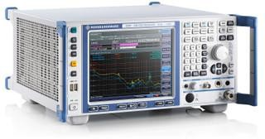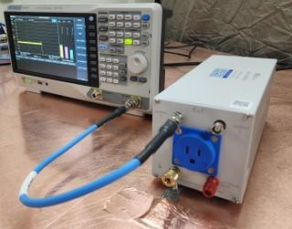

# Rohde & Schwarz ESRP3 EMI Test Receiver per CISPR 16-1-1

* 1. **Test Procedure :**

EMI test receiver and signal/spectrum analyzer combined in one box Resolution bandwidths in line with CISPR

Weighting detectors: max. peak, min. peak, average, RMS, quasi-peak, average with meter time constant, and RMS in line with current CISPR 16-1-1 version

Very fast FFT-based time domain scan as an option,Automatic test routines

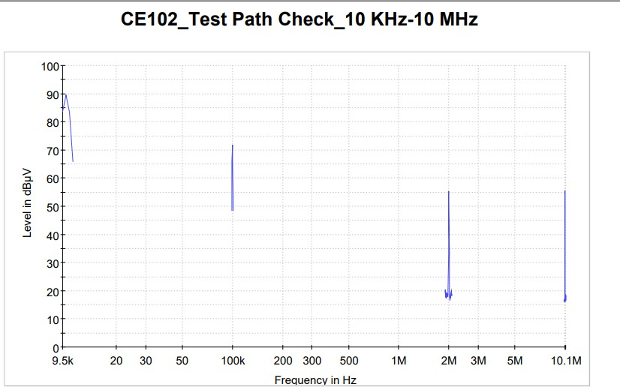

# Test Setup :

The test setup shall be as follows:

Maintain a basic test setup for the EUT as shown below

# A. Calibration.

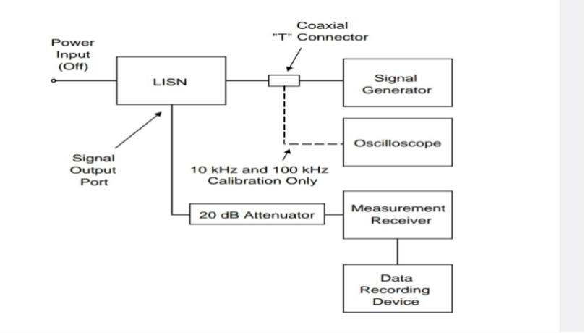

Configure the test setup for the measurement system check and ensure that the EUT power source is turned off.

* + 1. Connect the measurement receiver to the 20 dB attenuator on the signal output Port of the LISN.

# B.EUT testing.

* 1. Configure the test setup for compliance testing of the EUT as shown below.
  2. Connect the measurement receiver to the 20 dB attenuator on the signal output

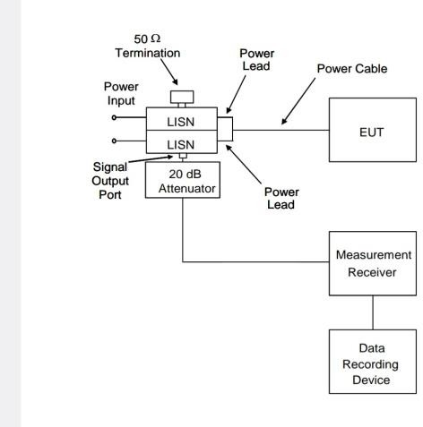

# C.Data presentation.

Data presentation shall be as follows:

1. Continuously and automatically plot amplitude versus frequency profiles on X-Y axis outputs. Manually gathered data is not acceptable except for plot verification.
2. Display the applicable limit on each plot.
3. Provide a minimum frequency resolution of 1% or twice the measurement receiver bandwidth, whichever is less stringent, and a minimum amplitude resolution of 1 dB for each plot.

d.Provide plots for both the measurement system check and measurement portions of the procedure.

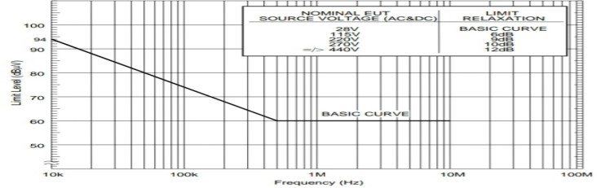

# RADIATED EMISSION-RE102:

* 1. **Purpose:**

RE102 is a military testing standard that is part of the MIL-STD-461 standard, which covers radiated emissions. The test measures unwanted signals emitted into the air from the device and its cables. It involves simulations of potential disturbances from magnetic sources, radio frequency sources, electrostatic discharge (ESD) sources, and electromagnetic pulse (EMP) sources.

* 1. **Requirement**:

MIL-STD 461 EMC testing standard RE102 refers to radiated emissions from equipment and subsystem enclosures, and all interconnecting cables. This standard military testing requirement does not apply to permanently mounted antennas.

This EMC MIL-461 test applies as follows:

* + - Ground 2 MHz to 18 GHz
    - Ships, surface 10 kHz to 18 GHz
    - Submarines 10 kHz to 18 GH

1. Aircraft (Army and Navy) 10 kHz to 18 GHz
   1. **Test Setup:**

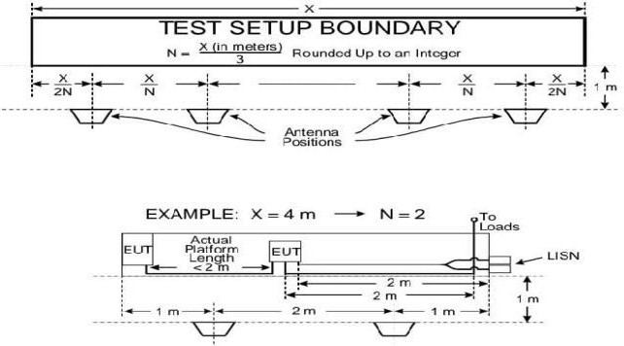

* 1. **Test equipment:**

1. Measurement receivers
2. Antennas ranging from 10 kHz to 18 GHz
3. Signal generators
4. Stub radiators
   1. **Testing Procedures:**
      * Ambient requirements must be verified and met. Plots are taken when required.
      * The measurement equipment is turned on and allowed sufficient time for stabilization.
      * Using the system check path, an evaluation of the overall measurement system from the coaxial cable end used at each antenna is performed. For rod antennas that use passive matching networks, the evaluation is performed at the centre frequency of each band. System check path verification is performed near the upper end of the affected frequency band. If readings are obtained that deviate by more than three dB, the source of the error is located and must be corrected.
      * An evaluation for each antenna to demonstrate that there is electrical continuity through the antenna is conducted. This is done by visually inspecting each antenna for damage.
      * After, each EUT is turned on and allowed sufficient time for stabilization.

Using the measurement path, the radiated emissions are finally determined from the EUT and its associated cabling. Lastly, measurements are taken for each antenna position.

1. **Radiated susceptibility-RS103:**
   1. **Purpose:**

This test procedure is used to verify the ability of the EUT and associated cabling to withstand electric fields.

* 1. **Requirement:**

The MIL-STD-461 lab testing requirement is applicable for equipment and subsystem enclosures. The EMC compliance test is also applicable to all interconnecting cables.

* + - 2 MHz to 30 MHz – Army, Navy and optional* for all others
    - 30 MHz to 18 GHz – All
    - 18 GHz to 40 GHz – Optional* for all

The EUT shall not exhibit any malfunction, degradation of performance, or deviation from specified indications, beyond the tolerances indicated in the individual equipment or subsystem specification,

The test equipment shall be as follows:

1. Signal generators
2. Power amplifiers
3. Receive antennas
   1. 1 GHz to 10 GHz, double ridge horns
   2. 10 GHz to 40 GHz, other antennas as approved by the procuring activity
4. Transmit antennas
5. Electric field sensors (physically small - electrically short)
6. Measurement receiver
7. Power meter
   1. **Test procedure:**
      * First, the measurement equipment and EUT is turned on and allowed ample time for stabilization.
      * After, the test area is assessed for potential RF hazards. The testing engineers take necessary precautions to assure the safety of all personnel.
      * Subsequently, the EUT test is performed. This is done over the required frequency ranges. The transmit antenna must be vertically polarized. The signal source is set to 1 kHz pulse modulation and 50% duty cycle.
      * An electric field is established at the start frequency. It is gradually increased until it reaches the applicable limit. The required frequency ranges are scanned. These must be in accordance with specified rates and durations.
      * If susceptibility is noted, the threshold must be determined. These steps are repeated above 30 MHz with the transmit antenna horizontally polarized. The test is also repeated for each transmitted antenna position.
   2. **Test setup**

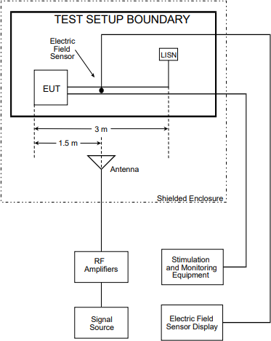

vice versa. Wireless devices like routers, wireless modems, game controllers, and Bluetooth devices also have antennas. Antennas are structures that help bridge the transition between guided waves and free space, converting electric power into electromagnetic waves. Infrared communication is an exception, but both devices rely on antennas.Antennas convert signals from transmission lines or guiding devices like co-axial cables into electromagnetic energy for transmission through free space. They can be used for both transmission and reception of radiation, collecting electrical signals and accepting radio waves from space.

# Antenna beam width:

Antenna beam width determines the expected signal strength given the direction and radiation distance of an antenna. The beam width will vary given a number of different factors such as the antenna type, design, orientation and radio frequency. Understanding beam width and how it influences a test environment is critical to accurate and repeatable tests.

# How beam width is measured:

To calculate an antenna beam width, it is first important to understand directional antennas and antenna gain. Gain is more than increased signal strength. It is directly associated with antenna directionality: increased signal strength in one direction is obtained by reducing signal strength in another. Antenna gain is referenced against a theoretical, pure omnidirectional antenna that radiates power equally in all directions, in the shape of a perfect sphere. Gain is measured in decibels (dB), which is a logarithmic scale since radio frequency (RF) power drops logarithmically with distance. All of these components of gain are important to consider during product testing to ensure that tests are correct, accurate and repeatable. The half-power value, also called the -3 dB point, which is represented by the red lines in below figure determines and defines the main RF lobe and its width, or beam width.

# Accounting for different antenna and frequency:

Antennas have a specific beam width pattern, but this pattern is not consistent across all frequencies. When testing, consider the frequency of operation to account for beam width differences. Higher frequencies have a narrower beam width and are more directional. The divergence of the beam is related to frequency by a formula, making it easy to account for these effects. A typical test setup in an anechoic chamber with a log periodic antenna, where its beamwidth at 1 m covers 0.536 m2 of testing area. This demonstrates the necessity of calculating the required testing distance relative to beamwidth and antenna.Antenna design plays a crucial role in selecting the best antenna for each test, considering factors like resonant frequency, bandwidth, polarization, and gain. Log periodic antennas have wide-frequency bandwidth and directionality, and their beamwidth is used for half-power testing. The half-power beamwidth and distance to the device under test provide necessary information for setting up a test environment.

# Gain:

Gain / Directivity: The extent to which an antenna focuses energy. In general gain is measured and directivity is calculated

Efficiency (dB) = Directivity (dB) – Gain (dB)

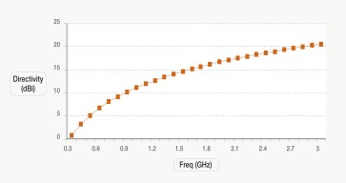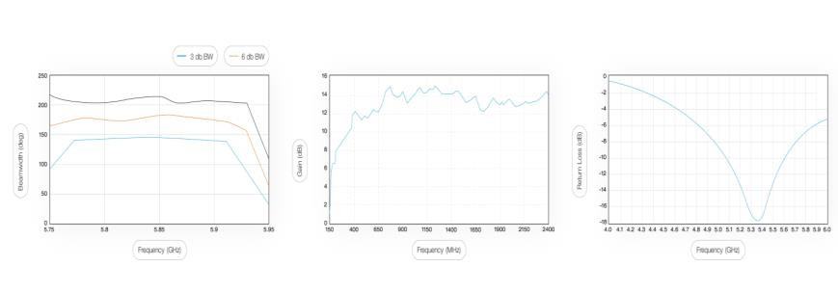

# Antenna measurements:

An isotropic radiator is a theoretical point source of electromagnetic energy that radiates

uniformly in all directions. The absolute power used is an isotropic radiator, and the measured gain relative to it is expressed in dBi. Directivity, calculated using antenna pattern or design parameters, should always be greater than the actual measured gain.

# Antenna impedance:

The antenna impedance (in ohms) is the impedance value seen at the antenna terminals. This does not mean the DC resistance, but the radiation resistance (whose job is to convert the

incoming signal to radiation) which varies with the frequency. As a result, using the antenna outside of its designed frequency will change its feed point impedance to an incorrect value. An incorrect value will cause the antenna to reflect some of the RF signal back and produce high VSWR.

# Universal spectral dipole source:

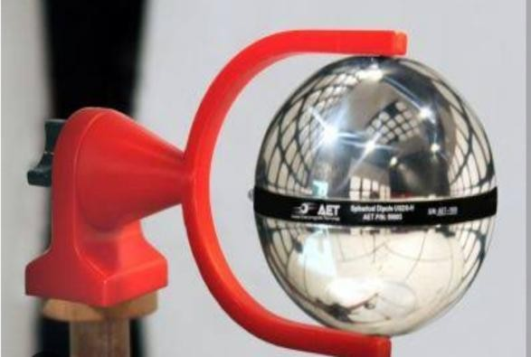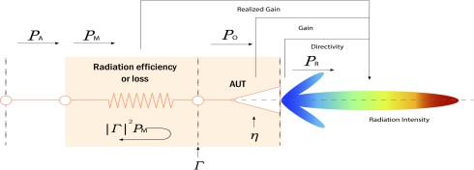

Applied Electromagnetic Technology, LLC (AET) offers the Universal Spherical Dipole Source (USDS), a broadband electric field comb generator RF source with Quasi-Peak detector test functionality. The USDS is traceable to the Precision Spherical Dipole Source (PSDS) design, developed by NIST. It is ideal for RF emission site comparisons, shielding measurements, quasi- peak detector verification, and verification of RF laboratory equipment. The USDS's spherical dipole antenna offers a highly uniform radiation pattern, easy use, and a small, 10 cm size for shielding effectiveness tests.

# EMI Receiver :

* 1. **Resolution bandwidth (RBW):**

Spectrum analyzers are useful tools for broadcast monitoring, RF component testing, and EMI troubleshooting. There are a number of common adjustments available with many modern analyzers that can optimize performance for a particular application. In this application note, we will introduce resolution bandwidth (RBW) and video bandwidth (VBW) and how they affect measurements.Bandwidth is defined as the span of frequencies that are the focus of a particular event. For example, the bandwidth of the transmission signal is the span of frequencies that the transmission occupies. The bandwidth of a measurement defines the range of frequencies that were used for the measurement.Ideally, you would like to set this bandwidth as narrow as possible, as that would give you the finest frequency resolution. The tradeoff is sweep time. The narrower the resolution bandwidth, the longer the sweep time, but if you sent the RBW too wide, you won’t see signals that are close to one another.In spectrum analysis, the resolution bandwidth (RBW) is defined as the frequency span of the final filter that is applied to the input signal. Smaller RBWs provide finer frequency resolution and the ability to differentiate signals that have frequencies that are closer together.

# Phase Noise:

Another factor that affects the frequency resolution of an analyzer is the phase noise. This is observed as a widening and increase in the noise amplitude near the center frequency of the signal. It is caused by the random thermal fluctuations of the oscillator used as a timing reference in the spectrum analyzer circuitry. These fluctuations cause the phase of the output clock signal to vary with time, very similar to jitter in a time-based system. This widening can cover up any small signals that may be near the frequency of interest. For meaningful measurements, select an instrument with lower phase noise than the signal source you are measuring.

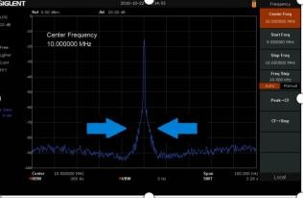

# Conversions related to Power and dB :

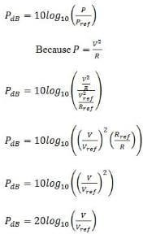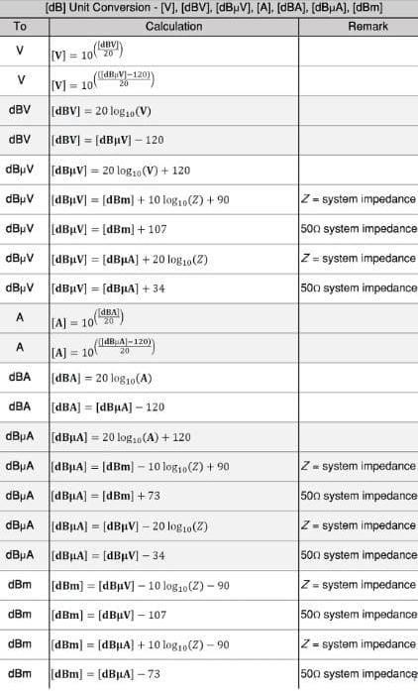

1. **Insertion Loss Measurement of Direction Coupler using VNA:**

Insertion loss, also known as attenuation, is a measure of how much signal power is lost as it passes through an EMI/EMC filter. It is expressed in decibels (dB) and is typically a negative value because the filter’s primary function is to reduce or attenuate unwanted signals.The relationship between insertion loss and frequency for several different filter circuit configurations with a full load in a balanced 50 Ω system.Insertion loss is a critical performance metric that determines how effectively the filter attenuates unwanted EMI signals and reduces their impact on sensitive electronic components.

# Directional Coupler:

[Directional couplers](https://www.werlatone.com/resources-directional-couplers/) are versatile aids when measuring RF/microwave power levels. Directional and bi-directional couplers provide the means to sample a small portion of the RF / microwave signal power through a transmission line with minimal disruption to the main line. Teamed with RF / microwave test instruments such as spectrum analyzers or electromagnetic-interference (EMI) receivers, couplers can provide sampled signals as part of better understanding the electromagnetic compatibility (EMC) of a new electronic design and whether it generates excess EMI. To qualify for sale in many markets, electronic products must pass rigorous EMC / EMI compliance testing and many developers of high-frequency components and systems have adopted EMC / EMI pre-compliance testing in preparation for a new product’s EMC / EMI compliance testing. Directional and bidirectional couplers can simplify EMC/EMI pre- compliance test efforts.

# What is VSWR?

We continue the explanation by ignoring the Voltage and Ratio parts for now and examine how a Standing Wave is created.

|  |  |
| --- | --- |
| 35 | |
|  |  |
| **14.3.How to Measure VSWR Using a Directional Coupler:**  A directional coupler is used in RF systems as a power divider. Directional couplers can be designed to sample power from a microwave circuit and measure it with an inductive probe, microwave ADC, or receiver. A directional coupler can be used to sample some power in a standing wave, which can be used for a voltage standing wave ratio measurement. In order to ensure high transmission of radiation between a source and a downstream device over the air, antennas need feed lines to be carefully matched to the antenna impedance. Impedance matching for antennas is a fundamental subject in RF design, but new designs also need to be evaluated to ensure the matching technique provides desired power transfer. The goal is to ensure the antenna has low return loss and insertion loss at the interface between the feed line and the radiating element. Impedance matching is also important in RF devices beyond antennas, and there is a metric that can be used to evaluate antennas on a finished PCB. The voltage standing wave ratio (VSWR) is one convenient metric that is linked to impedance matching within the desired antenna bandwidth. | |

|  |  |
| --- | --- |
| 36 | |
|  |  |
| One useful way to evaluate antenna impedance matching is to measure VSWR using a directional coupler. If you plan to use a directional coupler to meaure VSWR, here’s how to analyze your coupler design and the measurement results for your system.  A mathematical equation with numbers and symbols  Description automatically generated    With this equation, you can plug in the value of D and the measured voltages, and finally solve the above equation for the reflection coefficient. You can then use the result to calculate VSWR.  **14.4.VSWR of Transmitting Antennas using VNA:**  VSWR Stands for ‘Voltage Standing Wave Ratio’ and is used in EMC to specify the effect of mismatch presented to a test system signal.At microwave frequencies slotted lines became a way of accurately determining the ratio of the maximum voltage to the minimum voltage (the VSWR, symbol ‘s’), and because of the simplicity of measurement and the easy math associated with it, VSWR became an everyday parameter. As the name suggests, a slotted line is a length of waveguide with a slot along the top. A probe is moved along the slot and a detector gives the | |

voltage at any point on the line. Once you have obtained the two extremes of voltage you can determine the ratio of the two. Once you have this ratio it is easy to calculate the reflected power coefficient, symbol rho. The reflected power coefficient is the amount of power reflected back compared to the incident power.

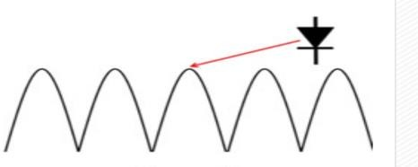

# SMITH CHART:

A Smith chart is a circular plot with a lot of interlaced circles on it..The Smith chart is a polar plot of the complex reflection coefficient (also called gamma and symbolized by Γ). Or, it is defined mathematically as the 1-port scattering parameter s or s11.

Recall that the complex reflection coefficient () for an impedance ZL attached to a transmission line with [characteristic impedance](http://www.antenna-theory.com/tutorial/txline/transmission2.php#impedance) Z0 is given by:

|  |  |  |
| --- | --- | --- |
|  | **equation for reflection coefficient** | **[Equation 1]** |

*For this Smith Chart tutorial, we will assume Z0 is 50 Ohms, which is often, but not always the case*. Note that the Smith Chart can be used with any value of Z0.

The complex reflection coefficient, or reflection coefficient, must have a magnitude between 0 and 1. As such, the set of all possible values for  must lie within the unit circle:

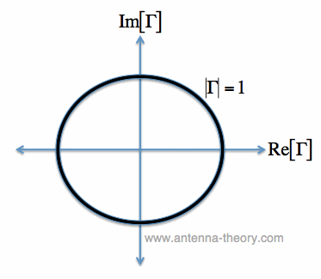

Figure 2. The Complex Reflection Coefficient must lie somewhere within the unit circle.

In Figure 2, we are plotting the set of all values for the complex reflection coefficient, along the real and imaginary axis. The center of the Smith Chart is the point where the reflection coefficient is zero. That is, this is the only point on the Smith Chart where no power is reflected by the load impedance.

The outter ring of the Smith Chart is where the magnitude of  is equal to 1. This is the black circle in Figure 1. Along this curve, all of the power is reflected by the load impedance.

Let's look at a few examples.

**Smith Chart Example 1**. Suppose smith chart tutorial=0.5.

From equation [1], we can solve for ZL to be:

|  |  |  |
| --- | --- | --- |
|  | **Smith Chart fundamentals** | **[Equation 2]** |

From equation [2], with Z0=50 Ohms, a reflection coefficient of 0.5 corresponds to a load impedance ZL=150 Ohms. We can plot gamma_1 on the smith chart:

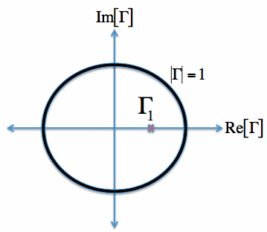.

Figure 3.  plotted on the Smith Chart.

Since  is entirely real, the point lies along the real gamma axis (x-axis) in Figure 3, and the imaginary axis value (y-axis) location is 0.

**Smith Chart Example 2**. Suppose  = -0.3 + i0.4

 is plotted on the Smith Chart in Figure 4:

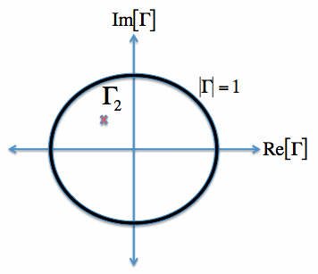

Figure 4.  plotted on the Smith Chart.

From Equation [2] and using Z0=50, we note that  corresponds to a load impedance

ZL = 20.27 + i*21.62 [Ohms].

**Smith Chart Example 3.**  = -i.

 is plotted on the Smith Chart in Figure 5:

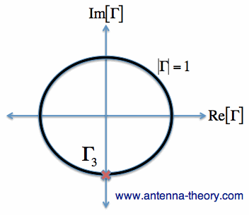

Figure 5. Smith Charts=-i plotted on the Smith Chart.

From Equation [2] and with Z0=50,  corresponds to a load impedance ZL = -i*50 Ohms. That is, the load impedance here is purely imaginary and negative, which indicates a purely capacitive load.

**VSWR on the Smith Chart**

Since [VSWR](http://www.antenna-theory.com/definitions/vswr.php) is only a function of the absolute value of , we can get the VSWR for a load from the Smith Chart as well. That is, a VSWR = 1 would be the center of the Smith Chart, and VSWR=3 would be a circle centered around the center of the Smith Chart, with magnitude =0.5. Circles centered at the origin of the Smith Chart are constant-VSWR circles. Note that the outer boundary of the Smith Chart (where =1) corresponds to a VSWR of infinity.

A Smith chart is developed by examining the load where the impedance must be matched. Instead of considering its impedance directly, you express its reflection coefficient ΓL, which is used to characterize a load (such as admittance, gain, and transconductance). The ΓL is more useful when dealing with RF frequencies. We know the reflection coefficient is defined as the ratio between the reflected voltage wave and the incident voltage wave:

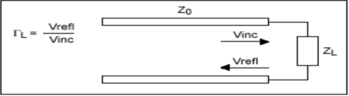

The amount of reflected signal from the load is dependent on the degree of mismatch between the source impedance and the load impedance. Its expression has been defined as follows:

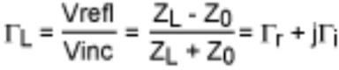

# Components of Smith Chart:

While understanding the Smith chart, we need to understand its components. There are various components depending on the type of Smith Chart which is as follows:

# Constant R Circles:

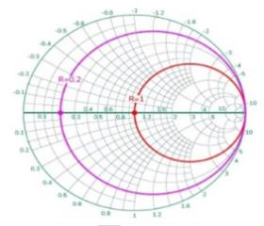

The figure given above represents the constant resistance circle. The horizontal line represents the resistance axis. It is used to represent the complex impedances of the resistive part of circuit. The center having the normalized resistance R=1. A circle (red color) tangent to the right side of the chart which passes through the prime center represents the constant normalized resistance circle with the constant resistance of 1. A similar circle (pink color) which passes through the resistance axis at R=0.2 represents the normalized resistance of 0.2 at every point on that circle.

# Constant X Circles

It is known as the constant reactance circle. The reactance axis lies across the the circumference of the Smith Chart. The figure given below represents the constant reactance circle.

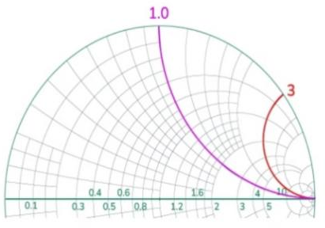

Every point along the curve (either pink or red) has the same value of reactance or imaginary part. The points lying on the pink curve have the normalized reactance of 1.0 while the points lying on the red curve have the normalized reactance of 3.0. The upper half of the Smith Chart have the positive reactance value (inductive) while the lower half of the Smith chart have the negative reactance value (capacitive).

# Advantages of Smith Chart:

1. Smith chart helps find the complex impedance and reflection coefficients. It makes the analysis of RF circuits easier.
2. It helps in finding the matching impedance of the network which helps in the maximum transfer of the power.
3. The reflection coefficients can be easily found with the help of Smith Charts. It helps in analyzing and visualizing the impedance mismatches. This helps prevent the signal reflections.
4. With the help of the Smith Chart, we can find the admittance of the circuit easily. It provides additional information about the circuit which enhances the flexibility in the circuit design.

# Applications of Smith Charts:

1. Transmission Line Analysis: Smith charts help in understanding and correcting issues in transmission lines, such as impedance mismatches and signal reflections, critical in high- frequency applications.
2. Antenna Design: Engineers use Smith charts to design and tune antennas for optimal performance by matching the antenna’s impedance to the transmission line’s impedance.
3. Filter Design: In the field of microwave and RF filter design Smith Charts play a role in attaining desired frequency response characteristics by manipulating component values and impedance transformations.
4. Amplifier Design: Engineers utilize Smith charts to optimize input output matching networks of amplifiers in order to maximize gain while minimizing noise levels and distortion.

5.S-parameter Analysis: These charts find application in vector network analyzers where they display S parameters providing information on how electrical signals propagate through a system.

# POWER MEASUREMENT USING USB POWER SENSORS:

* 1. **Average Power:**

Average power formula is P=ΔW/ΔT, and P = VI for electric circuits. There is no difference between power and average power. Thus, average power is commonly known as power only.Power has magnitude, but no direction and hence is known to be a scalar quantity. A system’s average power is directly proportional to the work done by the energy used and is inversely proportional to the time consumed to complete the work. As per average power definition, it is the total quantity of work done over a specific period.The average amount of energy utilised or work done per unit of time is known as average power. In specific cases, the average power is represented as power only. For example, when the work done over time increases, the average power also increases.

However, if there is no change in the quantity of work done over a continuously increasing time, the average power decreases. Thus, work that can be finished within a short-term duration demands higher average power, and the work done for an extended period has comparatively less average power requirement. You can read about it in a detailed average power definition. The SI Unit of average power is Watt and is represented as ‘w’ where Watt is Joules per second.

# Average Power Measurement:

Average power is the quantity of work carried out over a specific period. The dimensional formula of average power is L²MT-³. In the SI units, Watt measures average power. Therefore, the symbol for Watt is ‘W’. According to the International Systems Unit, for a total time of one second, if the total quantity of work done or the energy consumed is one joule, the average power is one Watt. Various other units used to measure average power are as follows: Horsepower, Foot pounds per minute, Ergs per second, BTU per hour, dBm, Tons of refrigeration, Calorie per hour (Cal/h).The above units of measuring average power are area-specific.

# Power sensors in Electromagnetic Interference (EMI) and Electromagnetic Compatibility (EMC) testing:

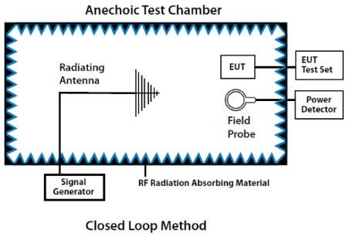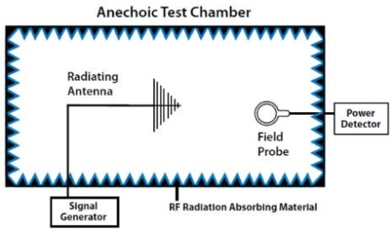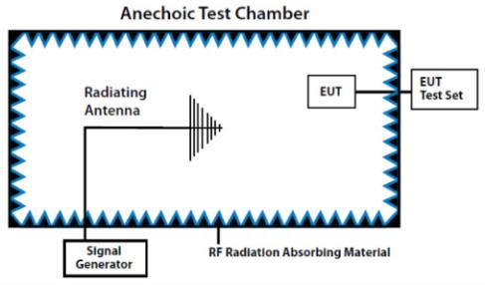

Power sensors are critical components in Electromagnetic Interference (EMI) and Electromagnetic Compatibility (EMC) testing.

# Performance checking of Biconical Antenna:

Radiation patterns are a crucial characteristic of antennas, describing how they distribute energy in space.The radiation pattern is a visual representation of the radiation emission from an antenna. Depending on the application, antennas may need 360-degree coverage or in the case of fixed point to point links, the antenna only needs to transmit in front. Below are the radiation patterns for dipole, yagi and parabola.

# Radiation Pattern of Biconical Antenna:

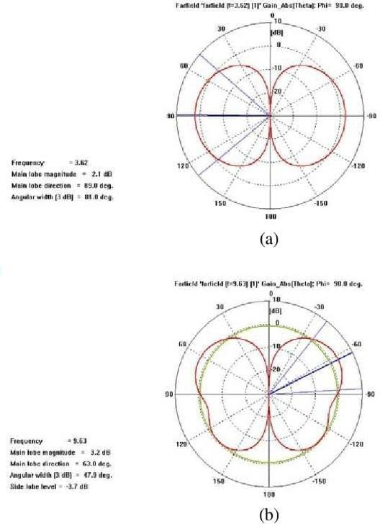

The radiation pattern of a wire biconical antenna is similar that of a half-wave dipole antenna. The wire biconical antenna displays an omnidirectional pattern (circular shape) in the H-plane and a bidirectional (eight-shaped) pattern in the E-plane. The antenna is used in field surveillance and spectrum monitoring applications because of its H-plane beam width.

The wire biconical antenna plays a major role in testing applications due to its advantages over other antennas. Its chief advantages are compact size and broadband characteristics along with omnidirectional radiation pattern. Regardless of the type of test (standard compliance test or simple field monitoring test), the antenna displays efficient performance characteristics

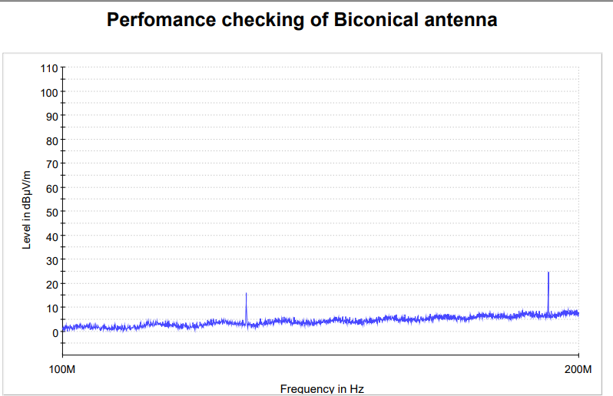

# CONCLUSION:

This internship has been an enriching experience, providing us with invaluable insights and practical knowledge that will undoubtedly shape our future careers.Throughout our time here, we had the privilege of working alongside talented and dedicated professionals who have generously shared their expertise and guidance. Their mentorship has not only enhanced our technical skills but also instilled in us the importance of collaboration, innovation, and continuous learning. The supportive and nurturing environment of the Vehicle Communication Division has made our journey enjoyable and valuable. We are thankful for the friendships we have formed and the sense of belonging we felt throughout our internship.As we move forward, we carry with us the lessons learned, the skills acquired, and the inspiration to achieve more. This internship has been a pivotal chapter in our professional development, and we are excited to apply what we have learned to future endeavors.

# REFERENCES:

1. MIL-STD-461 Standard Document.
2. [https://www.stqc.gov.in.](https://www.stqc.gov.in/emiemc-testing)
3. [Technical papers and case studies from DRDO publications.](https://www.stqc.gov.in/emiemc-testing)
4. [https://www.sciencedirect.com/](https://www.stqc.gov.in/emiemc-testing)
5. https://www.com-power.com/blog/why-emi-emc-testing-necessary#:~:text=The%20purpose%20of%20these%20tests%20is%20to%20ensure%20that%20any,within%20its%20expected%20operating%20environment.